**Practice Questions for DFA’s along with solutions**

Instructor: Asma Sanam Larik

Q1.



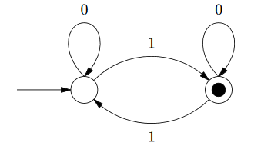

Q2.



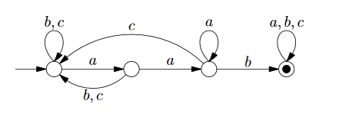

Q3.

Give a DFA that accepts any string that contains “abc” as substring

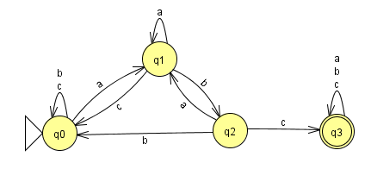

Q4.

Given a DFA that accepts any string that does not contain “abc” as substring

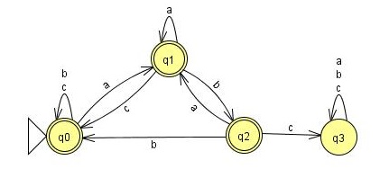

Q5.

Give a DFA that accepts set of strings that are at least length 4 and contains even number of 1’s

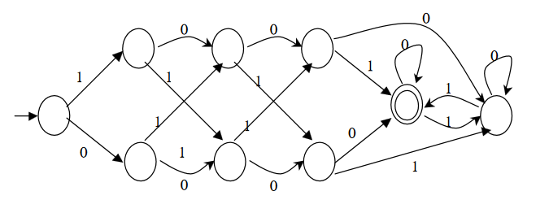

Q6. Set of all strings with number of 0’s in multiples of 5 and number of 1’s in multiples of 3

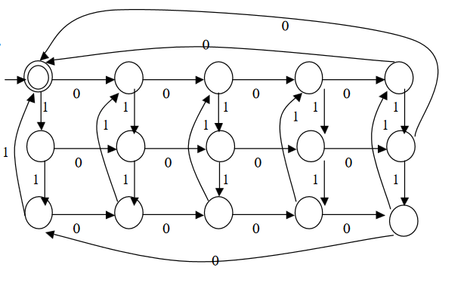

------------------------------------ The End ☺ ----------------------------------------